Virtual Cider Tasting –

April 30, 2021 7:00 PM

The Winehouse Cider Line-up
Dead Horse Cider Co. Cherry On Cider & Looking on the Bright Cide(r)
No Boats on Sundays Apple & Cranberry Rose’ Ciders,
Lost Craft Inc. Premium Craft Cider,
Guzman Riestra Sidra Brut Nature

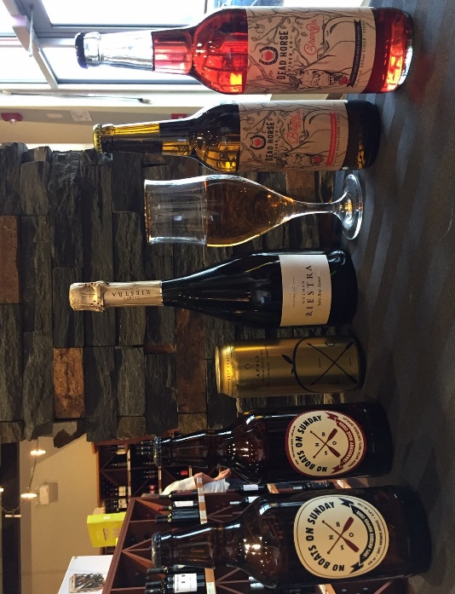

Host: Gord
The Winehouse is more than just wine! As the weather becomes warmer sometimes a nice cold fruit cider is just the right thing and The Winehouse carries a number of premium ciders from Spain, Nova Scotia, Ontario and Winkler!
Join Gord as he introduces the products and you will also hear from Marcus from the Dead Horse Cider Co. as he talks about their line-up of Manitoba-produced ciders.
Price: $55

